1. League table(consolidated, home, away)

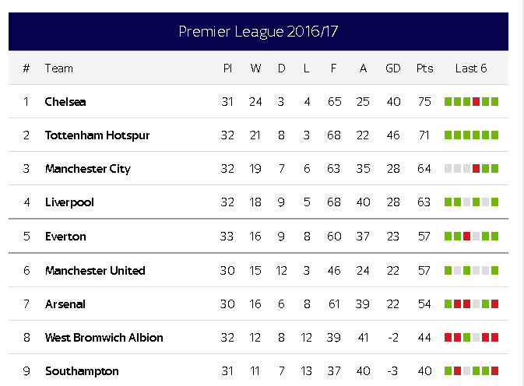

1. Worst and best record against opponent
2. Weather: is weather a deciding factor? Who plays well in worst weather condition?
3. Sentiment analysis using twitter,
4. Top 5 popular teams(team and tweets)
5. Top 5 popular players(player and number of tweets)
6. Most famous match of the season